

**Water Heater Project**

**Prepared by:**

-Ali Mahmoud Ali

- Muhammad Naser Ismai

-Ezz Eldine Khalid

-Aya Ahmed Yahia

Table of Contents

Introduction 3

Specifications 3

Temperature Setting 3

ON/OFF Behavior 4

Temperature Sensing 4

Heating/Cooling Elements 4

Seven Segments 5

Heating Element Led 5

Design 5

software 5

Hardware 6

Project Link 6

Flowchart 7

# **Introduction**

This Project aims to control the temperature of a water using a heater and cooler using on and off control. This will be done electrically using microcontroller and some other components like

1. 24C08 EEPROM, or use the internal.
2. Temp sensor (LM35, or equivalent DS18B20).
3. Cooling Element (Peltier).
4. Heating Element (3d ceramic heater).
5. 7-segments.
6. LEDs.
7. Push Buttons.
8. Solid State Relays.
9. Cooling fins & fans.

# **Specifications**

## **Temperature** **Setting**

1. The “Up” or “Down” buttons are used to change the required water temperature (set temperature).
2. The first “Up” or “Down” button press, entersthe temperature setting mode.
3. After entering temperature setting mode, a single “Up” button press increase the set temperature by 5 degrees.
4. After entering temperature setting mode, a single “Down” button press decrease the set temperature by 5 degrees.
5. The minimum possible set temperature is 35 degrees.
6. The maximum possible set temperature is 75 degrees.
7. The “External E2PROM” should save the set temperature once set.
8. If the electric water heater is turned OFF then ON, the stored set temperature should be retrieved from the “External E2PROM”.
9. 9. The initial set temperature is 60 degrees

## **ON/OFF Behavior**

1. If power is connected to the heater, the electric water heater is in OFF state.
2. If the “ON/OFF” button is released and the electric water heater is in OFF state, the electric water heater goes to ON state.
3. If the “ON/OFF” button is released and the electric water heater is in ON state, the electric water heater goes to OFF state.
4. In the OFF state, all display should be turned OFF

## **Temperature Sensing**

The temperature sensor measures the water temperature.

1. The water temperature should increase, if the “Heating Element” is ON.
2. The water temperature should decrease, if the “Cooling Element” is ON.
3. Temperature should be sensed once every 100 ms.
4. The decision to turn ON or OFF either the “Heating Element” or the “Cooling Element” based on the average of the last 10 temperature readings

## **Heating/Cooling Elements**

1. The “Heating Element” should be turned ON, if the current water temperature is less than the set temperature by 5 degrees.
2. The “Cooling Element” should be turned OFF, if the current water temperature is less than the set temperature by 5 degrees.
3. The “Heating Element” should be turned OFF, if the current water temperature is greater than the set temperature by 5 degrees.
4. The “Cooling Element” should be turned ON, if the current water temperature is greater than the set temperature by 5 degrees

## **Seven Segments**

1. Seven segment by default show the current water temperature or the set temperature.
2. By default, the 2 seven segment displays are show the current water temperature.
3. If the electric water heater is in the temperature setting mode, the 2 seven segment displays should blink every 1 second and show the set temperature.
4. In the temperature setting mode, every change in the set temperature should be reflected on the 2 seven segment displays.
5. The 2 seven segment displays should exit the temperature setting mode, if the “UP” and “Down” buttons are not pressed for 5 seconds

## **Heating Element Led**

1. If the “Heating Element” is ON, the “Heating Element Led” should blink every 1 second. 2. If the “Cooling Element” is OB, the “Heating Element Led” should be ON

# Design

## **software**

Software design The software is divided into layers MCAL, HAL, Application and Helper

In MCAL there are DIO, ADC, TWI, External interrupt and Timer 0 drivers where each driver is SOLID.

In HAL there are LED, Button, Heater, LM35, seven segment and EEPROM Drivers where each driver is SOLID.

In Application there is a header file and a source file same as each driver In Helper there are the types, bit math, registers and there is main file.

## **Hardware**

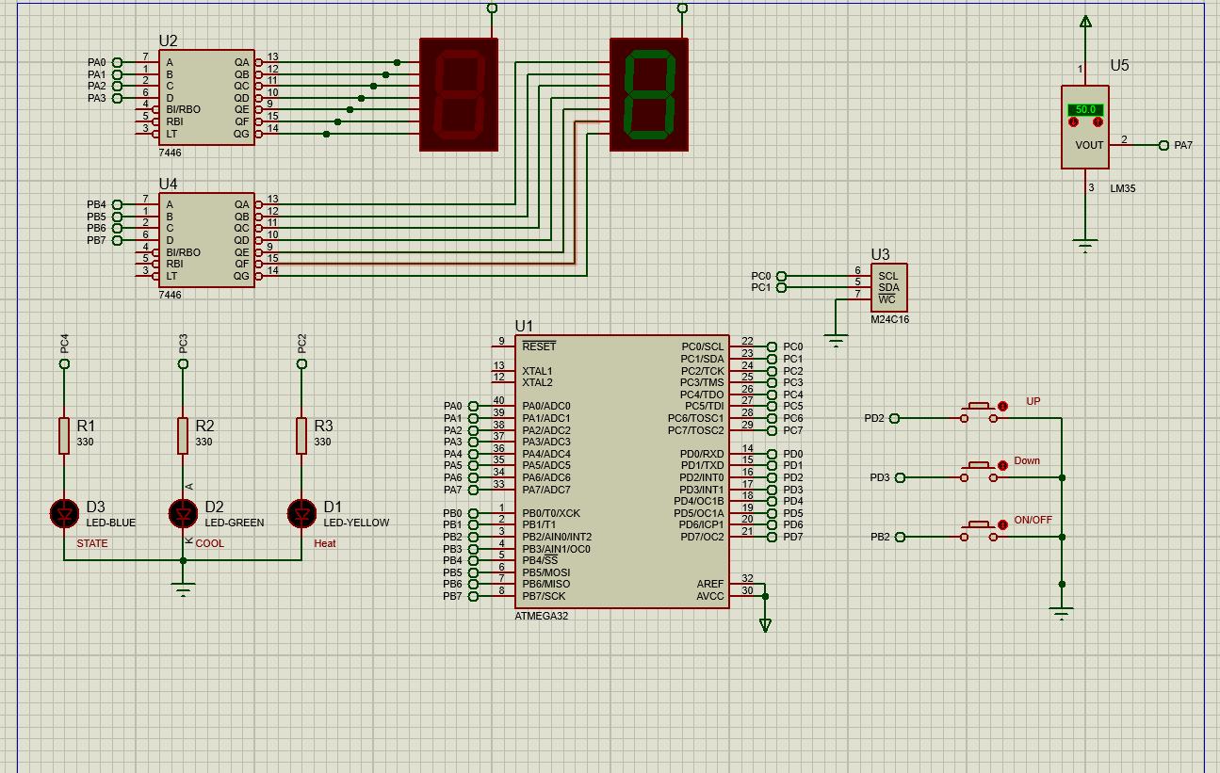

# **GitHub:**

# [MuhammadNasser12/ElectricalWaterHeater: AMIT Graduation Project (github.com)](https://github.com/MuhammadNasser12/ElectricalWaterHeater)

# Flowchart

